ENTITY RESOLUTION
Entity Resolution — TOO Taraz Prommontazh
Reconstructing the corporate and operational network behind ТОО «Тараз проммонтаж» (BIN 060940000171)
Taraz, Kazakhstan

Subject | TOO «Тараз проммонтаж» (TOO Taraz Prommontazh)
BIN | 060940000171
Jurisdiction | Kazakhstan — Taraz
Case type | Entity resolution / corporate network
Primary period | 2002–2026
Source basis | Kazakh and Russian public registers, government records, media and court documents

RESEARCH QUESTION
Determine which apparently related entities and individuals are demonstrably connected to TOO Taraz Prommontazh.

Prepared from public sources only. No private, paid or non-public data was used.

Entity Resolution — TOO Taraz Prommontazh

Executive Summary
This case reconstructs the corporate and operational network surrounding **TOO Taraz Prommontazh (ТОО «Тараз проммонтаж»), BIN 060940000171**, with the objective of determining which apparently related entities and individuals are demonstrably connected.
The investigation identified a strong historical and managerial relationship between **Taraz Prommontazh** and **TOO Spetsprommontazh (ТОО «Спецпроммонтаж»), BIN 020340017993**. The relationship is supported by four independent lines of evidence: both entities are separately identifiable legal persons; Taraz Prommontazh itself states that its business history began with Spetsprommontazh in 2002; registry-derived sources associate **Vadim Khorlantiyevich Tsoy (Цой Вадим Хорлантиевич)** with both entities at different points in time; and both companies are connected to **Karatai Turysov Street 15** in Taraz, although their registry addresses are not identical.
The evidence also indicates a later management transition within Spetsprommontazh: older registry-derived records identify **Vadim Tsoy** as its head, while more recent government-derived records identify **Alexander Vadimovich Tsoy (Цой Александр Вадимович)** as its current head and associate the company with Turysov 15. A separate individual-business record exists for Alexander Tsoy under **IIN 990218300094**, registered in 2020 in Taraz. The matching full name, patronymic and geography support a high-confidence identity resolution, but the public director record does not expose the IIN, so the two records are not treated as identifier-confirmed.
The research did **not** establish a formal legal succession, merger, rename, or transfer of ownership between Spetsprommontazh and Taraz Prommontazh. The two entities have different BINs and both continue to appear as separate legal persons in registry-derived data. Accordingly, the relationship is assessed as **strong historical/business continuity**, not proven legal succession.
The investigation also confirmed an independent economic and public-record profile for Vadim Tsoy. His individual entrepreneur record concerns real-estate activity, and an independently published 2020 list of Kazakhstan's largest individual taxpayers includes his IIN **660829300707**. He also had documented political/public activity: he stood as a candidate in the 2012 election to the Zhambyl Regional Maslikhat and, in 2019, was publicly identified as a member of the Zhambyl regional council of the National Chamber of Entrepreneurs "Atameken" and director of Taraz Prommontazh.
No comparable electoral, party-office or government-office record was identified for Alexander Tsoy in the indexed open-source layer examined for this case. This is a statement about the search result, not proof that no such activity exists.
The **ownership/shareholder layer remains unresolved**. Open sources consistently identify Vadim Tsoy as founder and/or managerial principal, but no accessible primary corporate record located in this investigation establishes his current equity percentage or the complete historical ownership structure. Likewise, the investigation did not establish cadastral ownership of the industrial property at Turysov 15 or prove that it is owned by Taraz Prommontazh or by Vadim Tsoy's individual business.

1. Research Objective
The objective was to reconstruct the corporate and operational network surrounding Taraz Prommontazh and resolve apparently related entities through:
- legal identifiers and registration history;
- historical corporate names and continuity;
- directors and founders;
- individual entrepreneurs;
- associated legal entities;
- addresses and address chronology;
- ownership indicators;
- government and regulatory records;
- media and public activity;
- industrial projects and counterparties.
The investigation deliberately distinguished between a **documented relationship** and a relationship inferred from coincidental similarities such as surname, address or business sector.

2. Methodology

2.1 Identifier-first approach
The principal identifier was:
**Taraz Prommontazh — BIN 060940000171.**
The investigation then pivoted to:
**BIN → legal name → registration → directors → founders → other entities → addresses → tax/regulatory footprint → public activity.**
The same method was applied independently to:
**Spetsprommontazh — BIN 020340017993.**
This prevented similarly named companies from being merged merely because they appeared in the same search results.

2.2 Multilingual search
Because Kazakhstan's governmental and business information is frequently published in both Russian and Kazakh, searches were performed using both linguistic forms.
Russian pivots included combinations of:
"ТОО", "Спецпроммонтаж", "Тараз проммонтаж", "руководитель", "учредитель", "суд", "закупки", "лицензия", "выборы".
Kazakh pivots included:
"ЖШС", "БСН", "басшысы", "құрылтайшысы", "заңды мекенжайы", "сот", "мемлекеттік сатып алу", "лицензия", "мәслихат", "сайлау".
The Kazakh-language layer independently reproduced the key identification of Spetsprommontazh and its current director, rather than producing a conflicting corporate identity.

2.3 Temporal triangulation
Current registry data was not treated as a complete representation of historical ownership or management.
Separate snapshots were compared to reconstruct:
- registration dates;
- earlier and later directors;
- historical addresses;
- appearance of related individual businesses.
This was particularly important for Spetsprommontazh, where older sources identify Vadim Tsoy and later government-derived sources identify Alexander Tsoy.

2.4 Evidence classification
Evidence was classified as:
**Confirmed** — directly supported by a government or otherwise authoritative record.
**Independently Corroborated** — supported by a source independent from the company's own publication.
**Company-Reported** — originating from the company's website or corporate materials.
**Inference / Hypothesis** — analytically plausible but not directly documented.
**Unverified** — the necessary evidence was not found in the accessible open-source layer.

3. Core Entity: TOO Taraz Prommontazh
**Legal name:** TOO "Taraz Prommontazh" **BIN:** 060940000171 **Registration:** 14 September 2006 in multiple registry-derived sources **Head:** Vadim Khorlantiyevich Tsoy **Primary OKED:** 41202 — construction of non-residential buildings **Secondary OKED:** 71121 — engineering and technical design **Enterprise size:** medium-sized enterprise.
A current government-derived record confirms:
- BIN 060940000171;
- Vadim Tsoy as head;
- legal address **Koroleva Street 15, Taraz**;
- medium-enterprise classification;
- VAT registration.
The registration date contains a minor source discrepancy. Several sources give **14 September 2006**, while one current registry-derived aggregator displays **25 September 2006** in its narrative field. Because the 14 September date is reproduced by multiple independent records, it is used here as the working registration date, while the discrepancy is retained rather than silently discarded.

4. Taraz Prommontazh: Legal and Operational Addresses
Two address layers have to be distinguished.

Legal address
**Koroleva Street 15, Taraz**
This address is present in current government-derived registry data and was already used in the official Enbek enterprise record published in 2018. That record associated Taraz Prommontazh with BIN 060940000171, Vadim Tsoy, and 174 employees.

Operational/public address
**Karatai Turysov Street 15, Taraz**
The company's own website identifies this location as its address. Yandex Maps independently places the company at **Karatai Turysov 15, floors 2–3**, with the same public telephone number as the company's website.
More importantly, an external judicial record concerning a 2018 commercial shipment identifies **Taraz Prommontazh as the purchaser at Turysov Street 15**. This is independent evidence that the address was used commercially by the company and was not merely introduced by a later corporate website.
A 2022 Zhambyl labour-inspection document also lists Taraz Prommontazh, BIN 060940000171, at **K. Turysova 15**.

Assessment
**Koroleva 15 = documented legal/registry address.**
**Turysov 15 = strongly corroborated operational/public address.**
The evidence does not establish the exact date on which the company began using Turysov 15, nor does it demonstrate that the two addresses represent a change of legal registration rather than simultaneous legal/operational use.

5. Historical Entity: TOO Spetsprommontazh
**Legal name:** TOO "Spetsprommontazh" **BIN:** 020340017993
Multiple registry-derived sources place its registration in **March 2002**. Some give **6 March 2002**, while another current source gives **11 March 2002**. The safe conclusion is therefore that the entity was registered in March 2002, with a five-day discrepancy between source records.
The historical profile is especially significant because it predates the 2006 creation of Taraz Prommontazh.
An older registry-derived record associates Spetsprommontazh with:
**Vadim Khorlantiyevich Tsoy**
and with:
**9 Yanvarya Street 4, Taraz.**
A more recent government-derived record identifies:
**Alexander Vadimovich Tsoy**
as the head of Spetsprommontazh and associates the entity with:
**Karatai Turysov Street 15.**
This establishes a documented temporal change in both management and address, although the precise dates of those changes were not recoverable from the accessible open-source records.

6. Taraz Prommontazh ↔ Spetsprommontazh
This is the central entity-resolution finding.
Taraz Prommontazh's own corporate history states:
**2002 — foundation of Spetsprommontazh; subsequent creation of Taraz Prommontazh and expansion of services.**
The same site identifies **Vadim Tsoy** as the founder and strategic head of Taraz Prommontazh.
This corporate statement is independently reinforced by registry-derived evidence linking Vadim Tsoy to Spetsprommontazh.
The address layer provides an additional link: Spetsprommontazh is currently associated with Turysov 15, while Taraz Prommontazh has been independently documented at that address since at least 2018.

Result
The following relationship is therefore assessed as:
**Strong historical/business connection — independently corroborated.**
The following stronger proposition is **not established**:
"Taraz Prommontazh is the legal successor of Spetsprommontazh."

The two companies have different BINs and continue to appear as separate legal persons. No accessible corporate document was located stating that one was formally merged into, renamed into, or reorganized into the other.
Accordingly, the defensible wording is:
**Taraz Prommontazh presents Spetsprommontazh as the origin of its business history, and independent registry/address evidence supports a strong historical relationship between the two entities; however, formal legal succession has not been established.**

7. Person Resolution: Vadim Khorlantiyevich Tsoy
**IIN:** 660829300707
Vadim Tsoy is directly associated with Taraz Prommontazh as its current head, and the company identifies him as its founder and strategic leader.
Historical registry-derived data independently links the same full name to Spetsprommontazh.
A separate individual entrepreneur record associates Vadim Tsoy with:
**OKED 68201 — rental and management of own real estate.**
The IIN **660829300707** is independently present in Kazakhstan's published list of the 1,000 largest individual taxpayers for 2020, where the activity is also identified as real-estate rental and management.

Assessment
The connection between Vadim Tsoy and:
- Taraz Prommontazh;
- historical Spetsprommontazh management;
- an individual real-estate business
is strongly established.
However, the investigation did **not** establish that the individual real-estate business owns the industrial premises at Turysov 15.

8. Person Resolution: Alexander Vadimovich Tsoy
**IIN:** 990218300094
A separate individual entrepreneur record exists for **Alexander Vadimovich Tsoy**, registered on **1 September 2020**, in Taraz, with activity in **passenger-car rental**.
Separately, the government-derived corporate layer identifies **Alexander Vadimovich Tsoy** as the current head of Spetsprommontazh, BIN 020340017993.
The following attributes match:
- full name;
- patronymic;
- city/region;
- corporate position;
- existence of the individual entrepreneur record.
This supports a **high-confidence identity resolution** between the individual entrepreneur and the corporate director.
It is not treated as identifier-confirmed because the public corporate record does not expose Alexander's IIN.

9. Vadim Tsoy ↔ Alexander Tsoy
The available data show:
**Vadim Khorlantiyevich Tsoy**
and later:
**Alexander Vadimovich Tsoy**
within the same historical corporate environment.
The patronymic **Vadimovich** is consistent with a father named Vadim, and the corporate sequence is also consistent with possible family succession.
However, no public document located in the investigation explicitly identifies Alexander as the son of **Vadim Khorlantiyevich Tsoy**.
Therefore:
**Possible familial relationship — unverified.**
The case should not state that they are father and son as an established fact.

10. Address Network
The address layer produces the following structure:
Figure 1. 10. Address Network — structure as presented in the source case.
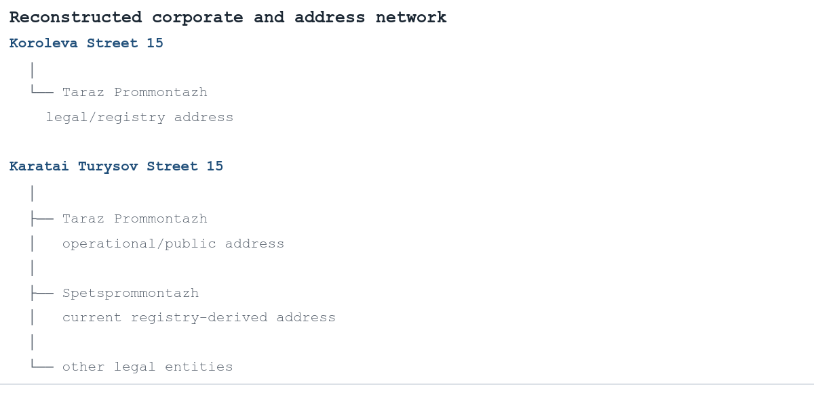
Source: structure reproduced verbatim from the source case report. Node and edge relationships are as stated there.
One independently identifiable co-located company is:
**TOO SON&PARTNERS LAW SERVICE / historical name "Bulekbaev i Ko"** **BIN 200140013155** registered in 2020 address: Karatai Turysov 15 head: Alexey Andreevich Son.
No evidence was found connecting SON&PARTNERS to the Tsoy entities other than the shared address.
Therefore:
**shared address ≠ affiliation.**
This is relevant because it prevents the address from being misinterpreted as an exclusive family or group-controlled site.

11. Asset Resolution: Turysov 15
Taraz Prommontazh describes its production infrastructure as a **0.761-hectare own production base**, with workshops for metal structures, custom equipment, corrugated sheet, welding and storage. The same description appears on the company's Russian and Kazakh-language websites.
The investigation independently established that:
- Taraz Prommontazh uses Turysov 15 operationally;
- the address appears in government and judicial records;
- Spetsprommontazh later appears at the same address.
However, no accessible cadastral or title document was located establishing:
- the cadastral number;
- the registered owner of the land;
- the registered owner of the buildings;
- date of construction;
- date of acquisition;
- historical transfers of ownership;
- ownership by Taraz Prommontazh;
- ownership by Vadim Tsoy's individual entrepreneur business.
Accordingly:
**Use of Turysov 15 = strongly corroborated.**
**Ownership of Turysov 15 = unresolved.**
The company's statement that the site is "own" is therefore retained as a **company-reported asset claim**, not upgraded to independently confirmed ownership.

12. Regulatory and Administrative Footprint
The company has a sustained government-record footprint beyond its own website.
The 2018 Enbek record identifies:
- BIN 060940000171;
- Vadim Tsoy;
- Koroleva 15;
- 174 employees.
A 2022 Zhambyl labour-inspection document lists the same BIN and identifies Taraz Prommontazh at Turysov 15 as a medium-sized enterprise.
A 2026 government document again lists Taraz Prommontazh with **174 employees**.
These records independently confirm that BIN 060940000171 represents a substantial operating enterprise rather than a dormant or nominal entity.
Registry-derived tax information also confirms VAT registration and a substantial tax footprint.

13. Licences
Taraz Prommontazh publishes three principal historical licence numbers:
- **17001516**, dated 31 January 2017;
- **0004435**, dated 10 January 2012;
- **000940**, dated 23 July 2010.
The company states that these licences concern construction and installation works, industrial equipment manufacture/installation, and design activities.
The licence numbers are reproduced by external business-directory sources, providing secondary corroboration. However, no accessible government licence-card record was retrieved during this investigation that independently bound every licence number to BIN 060940000171 with complete status and amendment history.
Therefore:
**Licence existence — medium-confidence, supported by company records and secondary reproduction.**
**Complete government-primary licence history — not established.**

14. Industrial and Project Network
Taraz Prommontazh presents itself as a contractor for the chemical, metallurgical and oil/gas industries and lists work in Taraz, Zhanatas, Balkhash, Zhezkazgan, Atyrau and Aksai, among other locations. The current Russian and Kazakh versions of the company website contain essentially the same project chronology.
The company also reports work involving major industrial organizations including Kazphosphate, Kazakhmys, KazZinc, KPO, Agip KCO and Tenova Delkor.
At least some of the detailed project descriptions are reproduced in external industry directories. For example, one source reproduces Taraz Prommontazh's reported participation in the reconstruction of an oxygen plant and phosphoric-acid production system at Kazphosphate facilities in 2014–2016.
However, these project descriptions are not uniformly corroborated by customer-side contracts, procurement decisions or official customer publications in the accessible open-source layer.
Accordingly:
**Industrial capability and geographic operating history — established at a general level.**
**Individual project/customer relationships — predominantly company-reported unless independently corroborated.**
One independent commercial record does exist: a 2018 court document records shipment of goods by Russian supplier ООО "Феррит" to Taraz Prommontazh at Turysov 15. This independently confirms an external commercial relationship and use of the address, although it does not independently prove the company's larger project claims.

15. Media and Public Activity

Vadim Tsoy
Vadim Tsoy has a documented public/political record.
In the **2012 election to the Zhambyl Regional Maslikhat**, he stood as a candidate in electoral district No. 9 and received **920 votes**. The seat was won by another candidate.
In 2019, Inbusiness identified **Vadim Tsoy as director of Taraz-Prommontazh and a member of the Zhambyl regional council of the National Chamber of Entrepreneurs "Atameken"**. The article also reported that he donated approximately **400,000 KZT** to the "Menің Атамекенім" relief effort for people affected by the Arys explosions.
These records demonstrate public and civic activity but do not, by themselves, establish political-party membership or a specific political ideology.

Alexander Tsoy
No material indexed evidence of:
- electoral candidacy;
- elected office;
- political-party office;
- government office
was identified for Alexander Vadimovich Tsoy in the searched open-source layer.
This negative finding should not be interpreted as proof that no such activity has ever existed.

Adverse media
The search did not identify a significant indexed body of independent reporting alleging major corruption, bankruptcy, criminal conduct or comparable corporate controversy involving Taraz Prommontazh, Vadim Tsoy or Alexander Tsoy.
This should be understood strictly as:
**No material adverse media record was identified in the searched indexed open-web layer.**

It is not equivalent to proving the absence of all litigation, regulatory events or non-indexed reporting.

16. Evidence Matrix
Table 1. Tabulated data under this section, as set out in the source case.
Relationship / finding | Assessment
Taraz Prommontazh = BIN 060940000171 | **Confirmed**
Vadim Tsoy = head of Taraz Prommontazh | **Confirmed**
Taraz Prommontazh founded in 2006 | **Confirmed / minor date discrepancy across sources**
Spetsprommontazh = BIN 020340017993 | **Confirmed**
Spetsprommontazh existed from March 2002 | **Confirmed; exact day disputed**
Vadim Tsoy ↔ Spetsprommontazh | **Strong historical link**
Taraz Prommontazh ↔ Spetsprommontazh | **Strong historical/business connection**
Formal legal succession | **Unverified**
Vadim Tsoy = founder of Taraz Prommontazh | **Company-reported; strongly consistent with registry history**
Alexander Tsoy = current head of Spetsprommontazh | **Confirmed in current government-derived layer**
Alexander IIN 990218300094 = same Alexander | **High-confidence identity resolution, not identifier-confirmed**
Vadim Tsoy ↔ Alexander Tsoy familial relation | **Unverified**
Taraz Prommontazh ↔ Turysov 15 | **Strongly independently corroborated**
Spetsprommontazh ↔ Turysov 15 | **Confirmed in current registry-derived data**
Taraz Prommontazh ↔ Koroleva 15 | **Confirmed as legal/registry address**
Vadim IP 660829300707 = real-estate activity | **Confirmed**
Vadim's ownership of Turysov 15 | **Unverified**
Taraz Prommontazh ownership of Turysov 15 | **Unverified**
SON&PARTNERS at Turysov 15 | **Confirmed co-location**
SON&PARTNERS affiliated with Tsoys | **Not established**
Licence numbers claimed by Taraz Prommontazh | **Medium confidence**
Specific industrial projects | **Mostly company-reported**
Vadim Tsoy 2012 electoral activity | **Confirmed**
Vadim Tsoy Atameken regional-council role in 2019 | **Independently reported**
Alexander Tsoy political activity | **No material indexed evidence identified**

17. Reconstructed Corporate Network
The strongest evidence-based reconstruction is:
Figure 2. 17. Reconstructed Corporate Network — structure as presented in the source case.
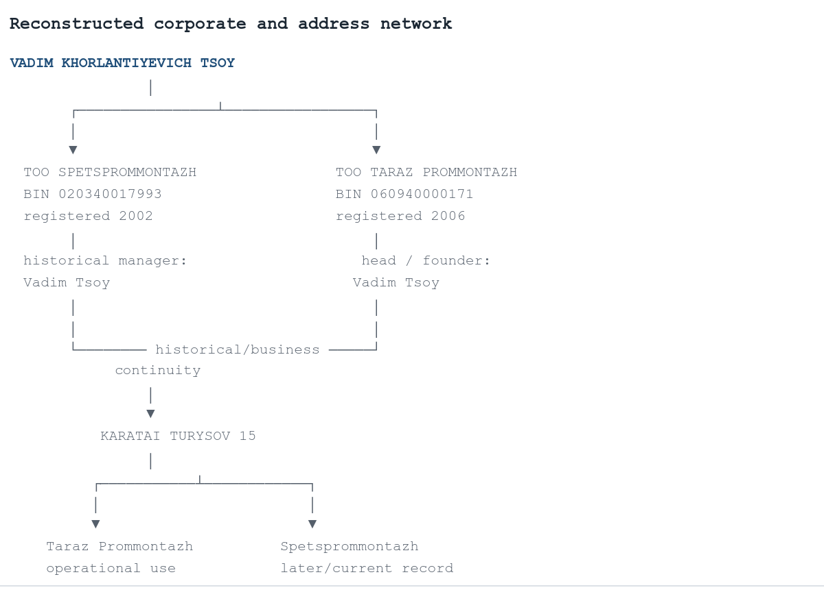
Source: structure reproduced verbatim from the source case report. Node and edge relationships are as stated there.
A second person node is:
Figure 3. 17. Reconstructed Corporate Network — structure as presented in the source case.
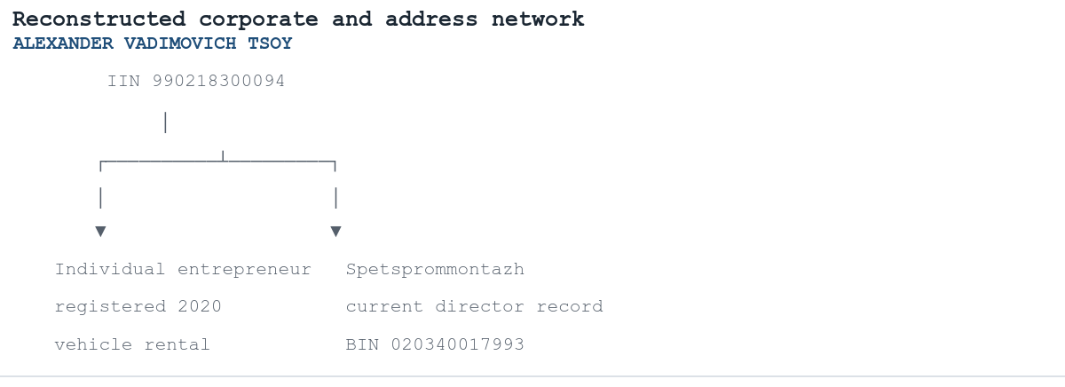
Source: structure reproduced verbatim from the source case report. Node and edge relationships are as stated there.
The possible relationship between Vadim and Alexander is intentionally left outside the confirmed graph:
Figure 4. 17. Reconstructed Corporate Network — structure as presented in the source case.

Source: structure reproduced verbatim from the source case report. Node and edge relationships are as stated there.

18. Analytical Conclusion
The investigation establishes a coherent corporate network around **Taraz Prommontazh (BIN 060940000171)**, but the strongest finding is historical rather than purely contemporary.
The evidence shows that **Spetsprommontazh (BIN 020340017993), founded in 2002, and Taraz Prommontazh, registered in 2006, are not merely similarly named companies.** Their relationship is supported by Taraz Prommontazh's own historical account, repeated registry-derived association of **Vadim Tsoy** with Spetsprommontazh, the subsequent appearance of **Alexander Vadimovich Tsoy** in Spetsprommontazh's management, and overlapping use of **Karatai Turysov 15**.
The most defensible characterization is therefore:
**Spetsprommontazh and Taraz Prommontazh form a strongly supported historical/business continuity cluster centered on Vadim Tsoy.**

A stronger statement — that Taraz Prommontazh is the legal successor, renamed entity or direct continuation in the formal corporate-law sense — **cannot be established from the accessible open-source evidence**. Both BINs remain separate and no primary reorganization document was located.
The subsequent emergence of **Alexander Vadimovich Tsoy** as head of Spetsprommontazh is significant for the network reconstruction. His separate 2020 individual-business record in Taraz is highly consistent with the same individual, although the public records examined do not expose a common unique identifier. A family relationship with Vadim Tsoy is plausible but not documented and should therefore remain outside the confirmed findings.
The address evidence also supports a physical relationship, but not property ownership. **Turysov 15** is independently established as a working address for Taraz Prommontazh and later appears as the address of Spetsprommontazh, while unrelated entities also use the same location. Therefore the address is a meaningful corporate-link indicator, but not by itself evidence of common ownership.
Finally, Vadim Tsoy's public profile extends beyond company management: he had documented participation in a **2012 Zhambyl Regional Maslikhat election** and was publicly identified in 2019 as both a Taraz Prommontazh director and member of the Zhambyl regional council of Atameken. No equivalent political profile was established for Alexander Tsoy.
The remaining unresolved issues are therefore narrow and clearly defined rather than structural:
**formal shareholder history, formal legal succession between the two BINs, the exact date of the Vadim-to-Alexander management transition, and cadastral ownership/history of Turysov 15.**
These gaps should remain explicitly marked as unresolved rather than filled through inference.

Sources
- 1. **TOO Taraz Prommontazh — corporate website / company history** — history from Spetsprommontazh, founder statement, address and corporate profile.
- 2. **TOO Taraz Prommontazh — Kazakh-language corporate website** — independent-language reproduction of company history, infrastructure and project chronology.
- 3. **MyTenge — Taraz Prommontazh, BIN 060940000171** — registry-derived identity, registration, director, legal address and activity.
- 4. **PRG / Business Analyst — Taraz Prommontazh** — current government-derived verification of BIN, director, OKED, VAT status and legal address.
- 5. **Enbek — Taraz Prommontazh enterprise profile** — 2018 government employment record, director, legal address and workforce.
- 6. **Adilet — 2026 Zhambyl employment quota document** — independent government confirmation of Taraz Prommontazh and 174 employees.
- 7. **PRG — Zhambyl labour-inspection planning document, 2022** — independent government record linking Taraz Prommontazh/BIN 060940000171 to Turysov 15.
- 8. **MyTenge — Spetsprommontazh, BIN 020340017993** — historical registry snapshot associating the entity with Vadim Tsoy and 9 Yanvarya 4.
- 9. **Uchet.kz — Spetsprommontazh** — independent reproduction of BIN, historical head and address.
- 10. **NIAC, Kazakh-language record — Spetsprommontazh** — current government-data-derived record identifying Alexander Vadimovich Tsoy as head.
- 11. **NIAC — Spetsprommontazh in OKED directory** — current director and Turysov 15 address.
- 12. **PRG — Alexander Vadimovich Tsoy, IIN 990218300094** — individual entrepreneur registration and activity.
- 13. **PRG — Vadim Khorlantiyevich Tsoy, IIN 660829300707** — individual business profile and real-estate activity.
- 14. **NIAC — 2020 list of Kazakhstan's largest individual taxpayers** — independent record for Vadim Tsoy's IIN 660829300707.
- 15. **ID Who Is Who — 2012 Zhambyl Regional Maslikhat election results** — electoral participation of Vadim Tsoy and vote count.
- 16. **Inbusiness — 28 June 2019** — Vadim Tsoy identified as Taraz Prommontazh director and Atameken regional council member; donation to Arys relief effort.
- 17. **11th Arbitration Court of Appeal / Garant — 2019 judgment** — external commercial record identifying Taraz Prommontazh at Turysov 15 in 2018.
- 18. **Nomad — 2016 Paryz results** — independent reporting identifying Taraz Prommontazh among leaders in the occupational safety category.
- 19. **TOO Taraz Prommontazh — licence page** — published licence numbers and claimed scope.
- 20. **3klik — Taraz Prommontazh profile** — reproduced historical project descriptions, including Kazphosphate work.
- 21. **Yandex Maps — Taraz Prommontazh** — independent operational address at Karatai Turysov 15.
- 22. **PRG / Kompra — SON&PARTNERS LAW SERVICE / historical "Bulekbaev i Ko"** — independent evidence of another legal entity using Turysov 15, demonstrating that the address is not exclusive to the Tsoy-related entities.

